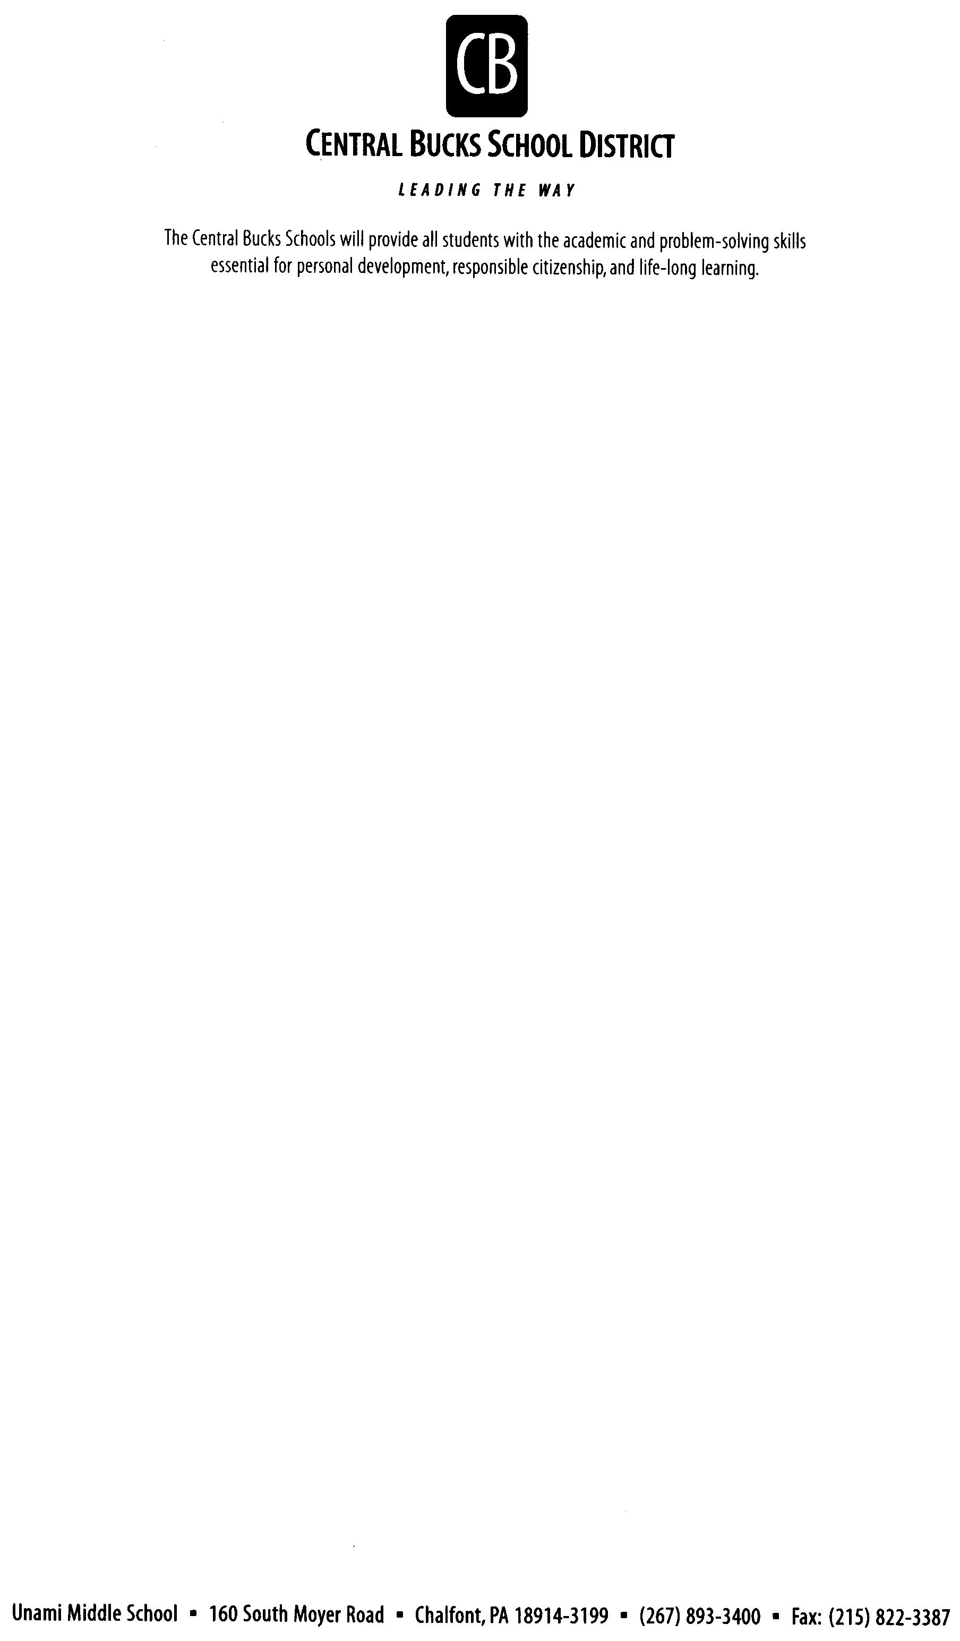
Dear Students and Parents/Guardians:

Welcome to the Eighth Grade Team Journey! We hope you are having a great summer and getting ready to begin a fabulous eighth-grade year! While you prepare for 8th grade, you are all encouraged to read one or more books over the summer. More information can be found on the Unami Library website: https://www.cbsd.org/domain/312
Over the summer, your teachers have collaborated to plan and focus on the goals for the 2025-2026 school year. We are looking forward to meeting all our students on Tuesday, September 2nd, and all their caregivers at Back to School Night on Thursday, September 25th. We know this year is going to be an awesome one, and we anticipate an exciting year filled with many new challenges, learning opportunities, and meaningful experiences.

As a team, we will unite to ensure everyone’s academic success, and we will work to help each other become stronger individuals who are able to grow, adapt, and learn from each experience. We pride ourselves on being a team that is welcoming, caring, and hardworking. If you have any questions, please reach out to Team Journey’s team leader, Mrs. Kim Keller, at kkeller@cbsd.org.

We hope you had time this summer to relax, rejuvenate, and read a good book! Enjoy these last days of summer. Relax, rest up, and have fun! We cannot wait to get started on a new JOURNEY in 25-26 with all of you! See you on September 2nd for the start of an amazing eighth-grade year!
Sincerely,
The Team Journey Teachers

